Application for approval of a Training Centre - Equine Track

(Applies to Full time residency programme applications and part-time residency applications)

NOTES:
Please check that you have the latest version of this form from the College web site www.evdc.info.
This form is not required when facilities are certified as appropriate by a Diplomate.
Name :
E-mail :

Name of main premises :
Address of main premises :
Date of previous approval : Delete if not applicable #
The original application should be used as the basis for any request for re-approval or amendment of facilities.
Changes and updates to previous submissions must be clearly described and highlighted to save the assessors' time.

I request approval of the training facilities described in this document and confirm that the descriptions given are an accurate representation of the current situation. I will inform the College Secretary should available facilities or equipment fall below the required standard before the next training review date.
My supervisor will acknowledge their awareness of this application by ticking the "OK" box associated with this document in the EVDC TMS. I understand that the application is not actually submitted until it has been set "OK". Once this has been done, I will notify the College Secretary of submission of this form.

Current Date :
Signature :

Description of Training Facilities Available to:
NAME

DO NOT FORGET TO UPDATE THE CONTENTS TABLE BEFORE CREATING YOUR PDF
Contents
Application for approval of a Trainee's Training Facilities 1
Description of Training Facilities Available to : 2
Guidance on preparing the document for submission 3
NOTES on use of this template 4
Guidance text 4
Premises (Buildings) 5
Description of practice premises: Site 1 5
Practice title and address 5
Public areas 5
Waiting area. 5
Consulting rooms 5
Diagnostic facilities 5
Surgical facilities 5
Library 5
Availability of urgently required supplies 5
Clinical records 5
General and dental operatory equipment: 5
Description of additional practice premises: Site 2 5
Title and address 5
Public areas 5
Waiting area. 5
Consulting rooms 6
Diagnostic facilities 6
Surgical facilities 6
Library 6
Availability of urgently required supplies 6
Clinical records 6
General and dental operatory equipment: 6
Clinical records 6
General medical records 6
Dental charts 6
Anaesthetic and hospitalisation record sheets 7
Client handouts
Non-dental equipment 7
General Dental Equipment:- Equine dentistry 8
_Toc343507828
Clinical examination 8
Dental radiography 8
Periodontics 8
Endodontics 8
Orthodontics: 8
Restorative: 8
Oral Surgery 8
8
Equine Dentistry 8
Photographs 9

Guidance on preparing the document for submission

This application should be prepared following the guidance notes here and elsewhere in the template.
Once the content has been added, the "Preparing the document for submission" section, plus unnecessary notes and example illustrations elsewhere in the template, should be deleted and the contents list updated before creating a PDF file for submission to the College via the Document Management System (DMS).
The final PDF file should be under 4 MB in size with an image resolution of between 200 and 300 dpi to ensure sufficient detail in the illustrations when the PDF file is viewed on screen at 200% zoom. If you are having problems with creating a suitable PDF file, please contact the College Secretary.

NOTES on use of this template
Text in black below the "Preparing the document for submission" section is required. Do not modify or delete any of it. If any of the required text is missing, a corrected document may be required to be submitted along with a document resubmission fee.

Guidance text
The template contains guidance text in green.
- Subheadings in green are suggestions. They should be modified to suite the described training facilities and changed to black text.
- Text in italics is an instruction, comment or suggestion. If it is in green, it can be deleted.
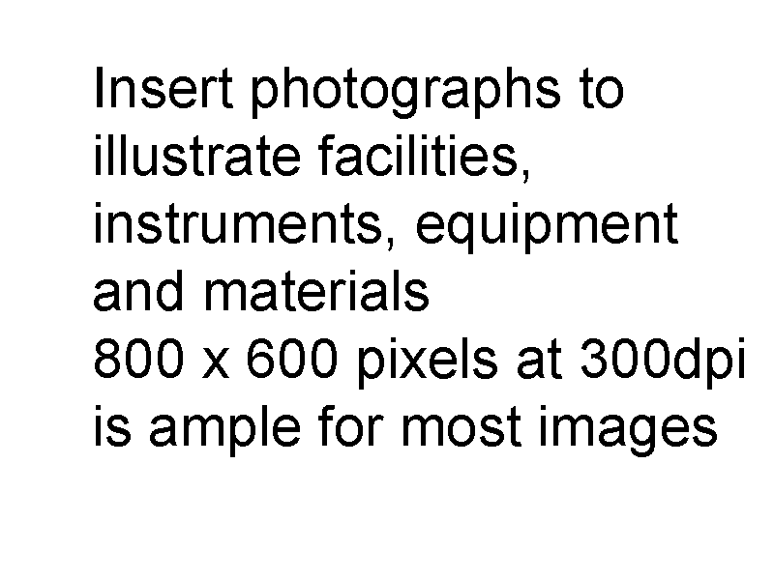
- Normal text in green should be replaced with appropriate text in BLACK, or deleted as appropriate
Illustrations are required
Insert photographs in appropriate places and use captions when appropriate. Scans of charts will need to be higher resolution and displayed larger than photographs.
When using photographs; crop and resize them to about 800 x 600 pixels BEFORE adding them to the document.
The image to the right is 800 x 600 pixels at 300 dpi 100% size. The image below is also 800 x 600 pixels. Its size on the page can be reduced by setting its scale to 33%.
As the document is intended for on-screen viewing, the above small on-page size is OK as those performing the assessment can zoom to 200% to see details.
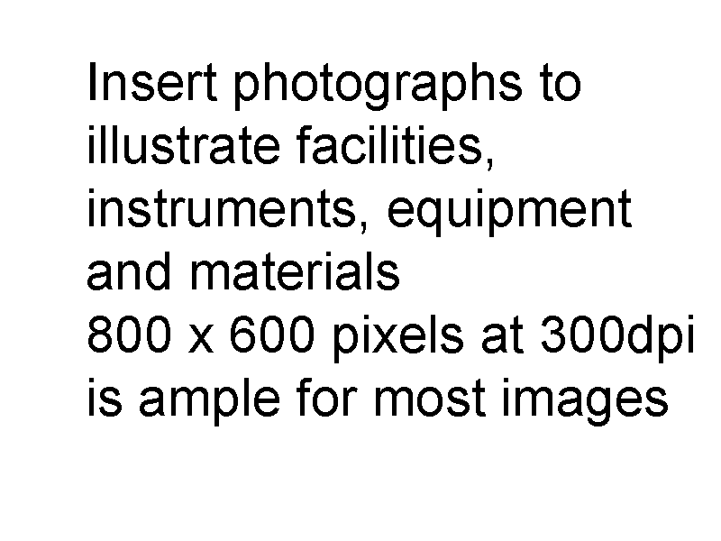

Premises (Buildings)

Description of practice premises: Site 1

Practice title and address
The Veterinary Practice, 123 Road, Town, City, Postcode, Country

Public areas
Enter description .............

Waiting area.
Enter description .............

Consulting rooms
Enter description .............

Diagnostic facilities
Enter description .............

Surgical facilities
Enter description .............

Library
Enter description .............

Availability of urgently required supplies
Enter details of local suppliers from whom you are able to obtain items at short notice. If you do not have a local supplier you will need to hold significant stocks of materials.

Clinical records
Note: Description of clinical records may be included here if there are multiple premises/practices involved and the records used at each differ. If they are the same at each practice/premises then describe them once under the specific heading below.

General and dental operatory equipment:
Note: Description of general equipment may be included here if there are multiple premises/practices involved and the facilities at each differ. If they are the same at each practice/premises then describe them once under the specific heading below.

Description of additional practice premises: Site 2

Title and address
Another Veterinary Practice, 999 The Avenue, City, Postcode, Country

Public areas
Enter description .............

Waiting area.
Enter description .............

Consulting rooms
Enter description .............

Diagnostic facilities
Enter description .............

Surgical facilities
Enter description .............

Library
Enter description .............

Availability of urgently required supplies
Enter details of local suppliers from whom you are able to obtain items at short notice. If you do not have a local supplier you will need to hold significant stocks of materials.

Clinical records
Note: Description of clinical records may be included here if there are multiple premises/practices involved and the records used at each differ. If they are the same at each practice/premises then describe them once under the specific heading below.

General and dental operatory equipment:
Note: Description of general equipment may be included here if there are multiple premises/practices involved and the facilities at each differ. If they are the same at each practice/premises then describe them once under the specific heading below.

Clinical records
If there are multiple premises with differing facilities and forms, describe them under the individual premises descriptions above.

General medical records
Enter description of how these are kept. If computerised, please name the system used. .............

Dental charts
Include images of an example chart. The images do NOT need to be full size. If you have problems incorporating them here, it is permissible to submit charts and client leaflets in a separate document, stating that fact here. Remember to include translations if they are not written in English. If charts are submitted separately, they should all be combined into a single document.

Equine dental chart (required)
Insert chart and translation here
REMEMBER to include translations if your documents are not in English. See the example below.

Insert chart and translation here

Anaesthetic/Sedation or hospitalisation record sheets
If you have problems incorporating them here, it is permissible to submit charts and client leaflets in a separate document, stating that fact here. Remember to include translations if they are not written in English. If charts are submitted separately, they should all be combined into a single document.

Client handouts

Specimens of any client handouts relevant to dentistry or specimen insurance report
Handout type
Insert handout and summary translation here
If you have problems incorporating them here, it is permissible to submit charts and client leaflets in a separate document, stating that fact here. Remember to include translations if they are not written in English. If charts are submitted separately, they should all be combined into a single document.

Non-dental equipment
If there are multiple premises with differing facilities, describe items in the individual premises descriptions above.

General and Operatory Equipment
Insert photographs.

Sterilization equipment
Enter description .............
Autoclave
Enter description .............
Cold sterilization
Enter description .............
Access to gas sterilization
Enter description .............

Equine dental equipment
Describe the equipment available in the order listed in the training and credentials document first column indicating whether it is onsite (column O), property of a visiting consultant (V) or not available (N) by ticking the appropriate column. Equipment for all routine diagnostic imaging and treatments and most advanced dental procedures will be expected on site by the end of any training programme. Specialised dental instrumentation, surgical instrumentation advanced diagnostic imaging and some implants that are only used by supervising consultants or at hospitals referred to and attended by the applicant can be indicated in the V column.
Item | Description | O | V | N

General Equipment

Oral examination

Sinoscopy

Radiography

Periodontics

Endodontics

Orthodontics

Restorative

Oral surgery

Health and safety

Insert photographs as indicated below to describe items in the table above in each category

General Dental Equipment:

