Application for approval of a Trainee's Training Facilities

Name :
E-mail :
Name of main premises :
Address of main premises :
Date of previous approval: Delete if not applicable

I request approval of the training facilities described in this document and confirm that the descriptions given are an accurate representation of the current situation. I will inform the College Secretary should available facilities or equipment fall below the required standard before the next training review date.

Current Date :
Signature :

Contents
Application for approval of a Trainee's Training Facilities 1
Description of Training Facilities Available to : 2
Guidance on preparing the document for submission 3
NOTES on use of this template 4
Guidance text 4
Premises (Buildings) 5
Description of practice premises: Site 1 5
Practice title and address 5
Public areas 5
Waiting area. 5
Consulting rooms 5
Diagnostic facilities 5
Surgical facilities 5
Library 5
Availability of urgently required supplies 5
Clinical records 5
General and dental operatory equipment: 5
Description of additional practice premises: Site 2 5
Title and address 5
Public areas 5
Waiting area. 5
Consulting rooms 6
Diagnostic facilities 6
Surgical facilities 6
Library 6
Availability of urgently required supplies 6
Clinical records 6
General and dental operatory equipment: 6
Clinical records 6
General medical records 6
Dental charts 6
Anaesthetic and hospitalisation record sheets 7
Client handouts 8
Non-dental equipment 8
Gas anaesthetic machines (types) 8
(Assorted) Anaesthetic monitoring equipment 8
General and Operatory Equipment 8
Sterilization equipment 8
Standard radiography facilities 9
Patient homeostasis support equipment 9
Dental operatory 9
General Dental Equipment: 10
Dental units, handpieces and burs 10
Clinical examination 11
Dental radiography 11
Periodontics 12
Endodontics 12
Orthodontics: 15
Restorative: 16
Oral Surgery 17
Lagomorph and Rodent Dentistry 18
Equine Dentistry 19
Other species 19

Guidance on preparing the document for submission

This application should be prepared following the guidance notes here and elsewhere in the template.
Once the content has been added, the "Preparing the document for submission" section, plus unnecessary notes and example illustrations elsewhere in the template, should be deleted and the contents list updated before creating a PDF file for submission to the College via the Training Management System (TMS).
The final PDF file should be under 4 MB in size with an image resolution of between 200 and 300 dpi to ensure sufficient detail in the illustrations when the PDF file is viewed on screen at 200% zoom. If you are having problems with creating a suitable PDF file, please contact the College Secretary.

NOTES on use of this template
Text in black below the "Preparing the document for submission" section is required. Do not modify or delete any of it. If any of the required text is missing, a corrected document may be required to be submitted along with a document resubmission fee.

Guidance text
The template contains guidance text in green.
- Subheadings in green are suggestions. They should be modified to suite the described training facilities and changed to black text.
- Text in italics is an instruction, comment or suggestion. If it is in green, it can be deleted.
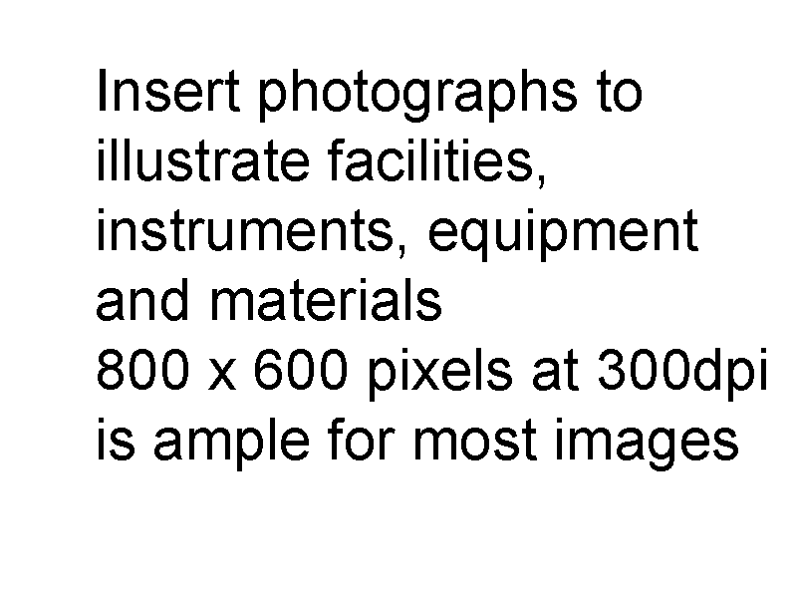
- Normal text in green should be replaced with appropriate text in BLACK, or deleted as appropriate
Illustrations are required
Insert photographs in appropriate places and use captions when appropriate. Scans of charts will need to be higher resolution and displayed larger than photographs.
When using photographs; crop and resize them to about 800 x 600 pixels BEFORE adding them to the document.
The image to the right is 800 x 600 pixels at 300 dpi 100% size. The image below is also 800 x 600 pixels. Its size on the page can be reduced by setting its scale to 33%.
As the document is intended for on-screen viewing, the above small on-page size is OK as those performing the assessment can zoom to 200% to see details.
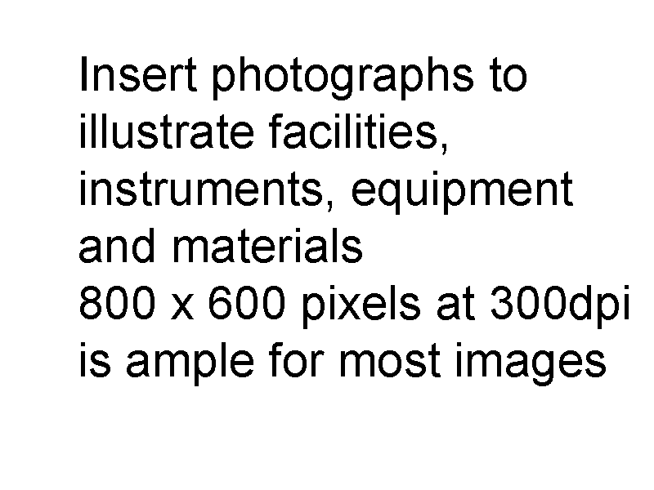

Premises (Buildings)

Description of practice premises: Site 1

Practice title and address
The Veterinary Practice, 123 Road, Town, City, Postcode, Country

Public areas
Enter description .............

Waiting area.
Enter description .............

Consulting rooms
Enter description .............

Diagnostic facilities
Enter description .............

Surgical facilities
Enter description .............

Library
Enter description .............

Availability of urgently required supplies
Enter details of local suppliers from whom you are able to obtain items at short notice. If you do not have a local supplier you will need to hold significant stocks of materials.

Clinical records
Note: Description of clinical records may be included here if there are multiple premises/practices involved and the records used at each differ. If they are the same at each practice/premises then describe them once under the specific heading below.

General and dental operatory equipment:
Note: Description of general equipment may be included here if there are multiple premises/practices involved and the facilities at each differ. If they are the same at each practice/premises then describe them once under the specific heading below.

Description of additional practice premises: Site 2

Title and address
Another Veterinary Practice, 999 The Avenue, City, Postcode, Country

Public areas
Enter description .............

Waiting area.
Enter description .............

Consulting rooms
Enter description .............

Diagnostic facilities
Enter description .............

Surgical facilities
Enter description .............

Library
Enter description .............

Availability of urgently required supplies
Enter details of local suppliers from whom you are able to obtain items at short notice. If you do not have a local supplier you will need to hold significant stocks of materials.

Clinical records
Note: Description of clinical records may be included here if there are multiple premises/practices involved and the records used at each differ. If they are the same at each practice/premises then describe them once under the specific heading below.

General and dental operatory equipment:
Note: Description of general equipment may be included here if there are multiple premises/practices involved and the facilities at each differ. If they are the same at each practice/premises then describe them once under the specific heading below.

Clinical records
If there are multiple premises with differing facilities and forms, describe them under the individual premises descriptions above.

General medical records
Enter description of how these are kept. If computerised, please name the system used. .............

Dental charts
Include images of charts for various species. The images do NOT need to be full size. They can be reduced to ½ size providing that the resolution is still OK when the final document is viewed at 200%.
If you have problems incorporating them here, it is permissible to submit charts and client leaflets in a separate document, stating that fact here. Remember to include translations if they are not written in English. If charts are submitted separately, they should all be combined into a single document.
Canine dental chart (required)
Insert chart and translation here
Feline dental chart (required)
Insert chart and translation here
REMEMBER to include translations if your documents are not in English. See the example below.
This chart is at the lowest acceptable resolution. It is just readable when viewed on-screen at 200% zoom.

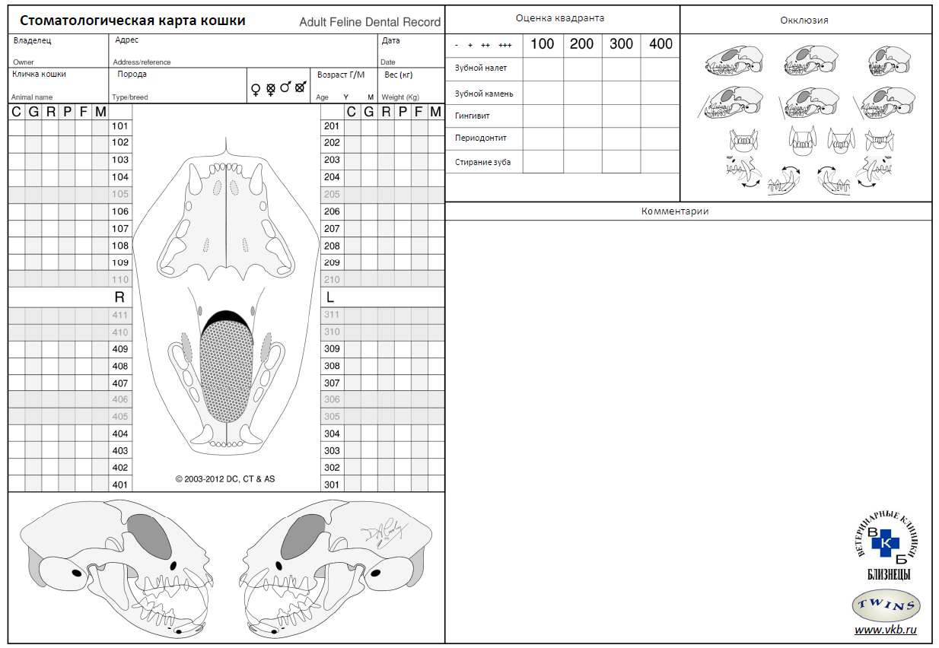
Feline dental chart in Russian: This has translations of most items built in, but the Quadrant assessment, Occlusion and Comments headings on the right side are not translated on the chart. The quadrant assessments are, Plaque, Calculus, Gingivitis, Periodontitis and Tooth wear (top to bottom).
Rabbit dental chart (required)
Insert chart and translation here
Rodent dental charts (required)
These can be multi- species charts – Two charts can be used for the two commonly seen dentition patterns: mouse/rat/gerbil/etc. and chinchilla/guinea pig/degu.
Insert charts and translation here
Equine dental charts (required if any equine work undertaken)
Insert chart and translation here
Other dental charts (if available)
Insert chart and translation here

Anaesthetic and hospitalisation record sheets
If you have problems incorporating them here, it is permissible to submit charts and client leaflets in a separate document, stating that fact here. Remember to include translations if they are not written in English. If charts are submitted separately, they should all be combined into a single document.
Anaesthetic record sheet (required)
Insert form and translation here
Inpatient care record sheet (if any)
Insert form and translation here
Critical care chart (if any)
Insert form and translation here

Client handouts
Handout type
Insert handout and summary translation here
If you have problems incorporating them here, it is permissible to submit charts and client leaflets in a separate document, stating that fact here. Remember to include translations if they are not written in English. If charts are submitted separately, they should all be combined into a single document.

Non-dental equipment
If there are multiple premises with differing facilities, describe items in the individual premises descriptions above.

Gas anaesthetic machines (types)
Enter description ............. Include details of waste gas scavenging if inhalational agents used.

(Assorted) Anaesthetic monitoring equipment
Enter description .............

General and Operatory Equipment
Insert photographs.

Sterilization equipment
Enter description .............
Autoclave
Enter description .............
Cold sterilization
Enter description .............
Access to gas sterilization
Enter description .............

Standard radiography facilities
Standard X-ray unit
Film cassettes and radiographic films or Digital system
Enter description .............

Patient homeostasis support equipment
Enter description ............. eg. Heat pads, i/v fluid pumps, syringe drivers etc.

Dental operatory
Insert photographs.
Enter descriptions .............
Storage facilities
Work surfaces
Operating table
Operating lights
Operator chairs
Emergency lighting

General Dental Equipment:

Dental units, handpieces and burs
The recommended minimum quantity is given in brackets (* = required). Do not alter this column. Enter the quantity you have at each site and if not kept at the centre indicate what items you carry to the centre when working there.
Number Number Number Number in
Required Items at Site 1 at Site 2 Mobile kit
(1) Air driven dental system 2 1 0
(2) High-speed air turbine handpieces 3 1 2
(2) Low-speed air motors 2 1 0
(2) Contra angle handpieces 2 2 3
(1) Reduction gear contra angle 0 0 1
(2) Polishing heads or handpieces
(0) Electric dental hand engine
(Assorted) FG burs: round, pear and fissure.
Provide a list of most frequently used types
702 TC 20 20 50
2 Round TC 5 5 5
4 Round TC 5 5 5
303 Diamond, coarse 10 10 5
Other 50 50 0
(Assorted) RA/CA burs
Provide a list of most frequently used types
Finishing stones 0 0 assorted
Finishing discs set set 0
Sizes ½ to 8 round * * many
(Assorted) HP burs
Provide a list of most frequently used types
Rabbit molar bur, diamond round end cylinder 0 0 1
8 Round, Ash surgical 6 6 10
702 Ash surgical 6 6 10

(1) Safety glasses
(Assorted) Disposable protective items (masks, gloves)
Insert photographs: Use a caption when appropriate.

Clinical examination
The recommended minimum quantity is given in brackets. Do not alter this column. Enter the quantity you have at this location and if not kept at the centre indicate what items you carry to the centre when working there.
Required Items Site1 Mobile kit
(1) Dental mirror
(4) Explorers/probes
(1) Magnification – 2.5 or 3 surgical loupes
(1) Lighting - oral or surgical
(1) Intraoral camera and films or digital camera

Dental radiography
The recommended minimum quantity is given in brackets. Do not alter this column. Enter the quantity you have at this location and if not kept at the centre indicate what items you carry to the centre when working there.
Required Items Site1 Mobile kit
(1) X-ray viewing box
(required even if using digital system as cases may be referred with films)
(1) Dental X-ray unit
(Assorted) Dental radiographic films or sensors
Provide a list of available sizes/types
Note size 2 and size 4 equivalent sizes are required
(*) Processing facilities
Provide details
Digital system
Automatic or chair-side developer
(Assorted) Film clips
Radiographic film ID and storage
(Assorted) Radiographic safety equipment

Insert photographs.

Periodontics
The recommended minimum quantity is given in brackets. Do not alter this column. Enter the quantity you have at this location and if not kept at the centre indicate what items you carry to the centre when working there.
Required Items Site1 Mobile kit
(1) Power scaler: ultrasonic or sonic
Provide details
(Assorted) Tips for scaler
Provide details
(Assorted) Hand scalers
Provide details
(Assorted) Hand curettes
Provide details
(2) Periosteal elevators
(Assorted) Sharpening stones & accessories
(*) Polishing paste
(*) Flour pumice or equivalent
(Assorted) Polishing cups
(0) Polishing brushes
(*) Plaque disclosing solution
(Assorted) Home care products
Provide details
(pastes, solutions, gels, sprays, treats, brushes, etc.)
Insert photographs: Use a caption when appropriate.

Endodontics
The recommended minimum quantity is given in brackets. Do not alter this column. Enter the quantity you have at this location and if not kept at the centre indicate what items you carry to the centre when working there.
Required Items Site1 Mobile kit
(1) Endodontic organizer
Endodontic hand files
(*) Note that all sizes from 8 to 140 are required in
25-31 length, but they do not need to be of the same
type throughout the size range
25-31 mm ISO 8 to 10 (pathfinder) files
25-31 mm ISO 10 to 80 K- files or equivalent
25-31 mm ISO 10 to 80 K- reamers
25-31 mm ISO 15 to 80 H-files or equivalent
25-31 mm ISO 90 to 140 K-files
25-31 mm ISO 15 to 40 NiTi files (H and/or K)
(*) Note that all sizes from 15 to 120 are required in
veterinary lengths, but they do not need to be of the same
type throughout the size range. NOTE: Veterinary length
files may be ISO taper (16mm) or have double
length (32mm) working ends.
40-60 mm # 15 to 40 H- files
40-60 mm # 45 to 80 H- files
40-60 mm # 15 to 40 H- files NiTi

40-60 mm # 45 to 80 H- files NiTi
40-60 mm # 90 to 120 H- files
40-60 mm # 15 to 40 K-reamers
40-60 mm # 45 to 80 K-reamers
Endodontic engine systems
(0) Endodontic hand engine
Provide details if used
(0) Endodontic handpiece
Provide details if used
(0) Endodontic engine files
Provide details if used
Endodontic materials
(*) Gutta percha (GP) in ranges of sizes:
(Assorted) 25-31 mm ISO 15 to 140
(0) 25-31 mm Non-ISO sizes
Provide details if used
(Assorted) 40-60 mm in # 15 to 120
with taper matching the type of files used
(0) Heated system GP
Provide details if used
Insert photographs.

Required Items Site1 Mobile kit
(Assorted) Paper points in range of sizes:
(*) 25-31 mm ISO 15 to 140
(0) 25-31 mm Non-ISO sizes
(*) 40-60 mm in # 15 to 120
(*) Endodontic stops
(1) Endodontic ruler
(*) Irrigation needles – range of sizes
Provide details
(1 set) Spreaders (human length)
(1 set) Pluggers (human length)
(1 set) Pluggers (veterinary length)
(1 set) Spreaders (veterinary length)
(Assorted) Barbed broaches (human length)
(Assorted) Barbed broaches (veterinary length)
(*) Irrigant solutions
Provide details
(*) Chelating agent
Provide details
(Assorted) Spiral fillers –(human length)
(Assorted) Spiral fillers –(veterinary length)
(*) Sealer cements
Provide details
(*) Retrograde filling material
Provide details
(*) Calcium hydroxide powder and/or paste
Provide details
(*) Calcium hydroxide sealer/cement
Provide details
(0) MTA
(*) Mixing slab or mixing paper
(*) Assorted cement spatulas

Orthodontics:
The recommended minimum quantity is given in brackets. Do not alter this column. Enter the quantity you have at this location and if not kept at the centre indicate what items you carry to the centre when working there.

Required Items Site1 Mobile kit
Impression materials –
see Restorative
Acrylic & temporary crown material –
see Restorative and Oral Surgery
Wire bending pliers and cutters –
see Oral Surgery
(*) Dental laboratory (orthodontic appliances)
Provide details
(0) Stone spatula
(0) Dental stone – type (III or IV)
(0) Dental vibrator
(*) Source of orthodontics requirements
Provide details if supplies are not available
(0) Orthodontic bonding agent
(0) Orthodontic brackets & buttons
(0) Orthodontic (spring) wires
(0) Power chains, elastic ligature, elastics
(0) Bracket application instrument
(0) Orthodontic bracket removal instrument
(0) Orthodontic pliers
(*) Model storage facilities
Insert photographs: Use a caption when appropriate.

Restorative:
The recommended minimum quantity is given in brackets. Do not alter this column. Enter the quantity you have at this location and if not kept at the centre indicate what items you carry to the centre when working there.

Required Items Site1 Mobile kit
(*) Dental laboratory (prosthodontics)
Provide details
(1 set) Composite (light cure)
(Assorted) Plastic filling instruments
(1) Enamel etching agent
(1) Dentinal bonding agent
(Assorted) Composite finishing points, disks, etc.
Provide details
(1) Glass ionomer (chemical cured)
Required for emergency use if curing lights fail
(2) Curing lights
(1) Light curing safety glasses or shield
(Assorted) Finishing burs
(0) Other restorative materials
Resin modified glass ionomer
Compomer
Amalgam
Provide details
For amalgam, the necessary equipment needs to be listed:
Amalgamator/triturator or mortar/pestle
Amalgam well
Amalgam carrier or –pistol
Various hand instruments (condenser, carver, and burnisher)
Safety-waste box for amalgam waste
(0) Impressions trays – full jaw
(0) Impressions trays – for crown preparations
(1) Custom tray material
(*) Impression materials
Provide details
(*) Bite registration material
Can be a suitable impression material
(Assorted) Crown prep burs
(Assorted) Crown prep finishing burs
(0) Luting cement for crowns and bridges
(0) Retraction cord
(0) Cord packing instrument
(1) Haemostatic solution
Insert photographs: Use a caption when appropriate.

Oral Surgery
The recommended minimum quantity is given in brackets. Do not alter this column. Enter the quantity you have at this location and if not kept at the centre indicate what items you carry to the centre when working there.
Required Items Site1 Mobile kit
(*) Surgical instrument kits
Provide details: i.e.
list contents of sets of surgical instruments
used for oral surgery, including drapes,
swabs etc.
(Assorted) Orthopaedic twisting wire
(1) Wire twisting forceps
(1) Wire bending pliers
(1) Wire cutters (small)
(Assorted) Acrylic burs
(1) Acrylic or temporary crown material
(1) Extraction forceps
(Assorted) Elevators - range of types and sizes
Provide details
(Assorted) Luxation instruments – range of sizes
Provide details
(Assorted) Periosteal elevators
(Assorted) Surgical blades
(Assorted) Suture materials
Provide details
(0) Grafting materials
Provide details

Insert photographs.

Lagomorph and Rodent Dentistry
The recommended minimum quantity is given in brackets. Do not alter this column. Enter the quantity you have at this location and if not kept at the centre indicate what items you carry to the centre when working there.
Required Items Site1 Mobile kit
(Assorted) Range of cheek pouch dilators
(1) Mouth gag
(0) Set of cheek dilators
(0) HP bur guard
(Assorted) HP burs suitable for occlusal adjustment
Provide details.
(0) Fine grain diamond tooth rasp
(Assorted) Extraction instruments
Provide details
Cheek tooth extraction forceps
Cheek tooth luxator
Incisor tooth luxator
Photographs: Use a caption when appropriate.

Equine Dentistry
If you are involved in equine dentistry, please list your equine instruments, equipment, materials etc. providing details as appropriate
Required Items Site1 Mobile kit
(0) Mouth gag
(0) Viewing devices
(0) Tooth rasps
(0) Power rasp
(0) Hand instruments
(0) Extraction instruments
(0) Surgical instruments
(0) Anaesthetic equipment
(0) Other
Photographs: Use a caption when appropriate.

Other species
If you work on other species that require special instruments, equipment, etc., please list what you have available here, providing details as appropriate.
Required Items Site1 Mobile kit
(0) ?

